

Software Testing Documentation

DeepCells – Cancer Prediction System

Version 1.0

Printing Date

Department and Faculty

Prepared by: Ruhul Quddus Tamim

Revision Page
- Overview
This test plan describes the testing approach which is the User Acceptance Testing (UAT) and overall framework that will drive the testing of this project.
The document introduces:
❖ Test Strategy: rules the test will be based on, including the givens of the project (e.g.: start / end dates, objectives, assumptions); description of the process to set up a valid test (e.g.: entry / exit criteria, creation of test cases, specific tasks to perform, scheduling, data strategy).
❖ Execution Strategy: describes how the test will be performed and process to identify and report defects, and to fix and implement fixes.
❖ Test Management: process to handle the logistics of the test and all the events that come up during execution (e.g.: communications, escalation procedures, risk and mitigation, team roster).

- Target Audience
Patients and Doctors

- Project Team Members
Ruhul Quddus Tamim

- Version Control History
Version | Primary Author(s) | Description of Version | Date Completed
1.0 | Ruhul Quddus Tamim | STD | 05/06/2022

Note:
This template is an annotated outline for a software testing document. It is based on IEEE standards 829, 1008, 1012 and 1012a. This document covers: unit testing (the verification of individual sub-systems or components of the system against their specifications), integration testing (the testing of inter-operating sub-systems or components against their specifications) and system testing (both verification against the system specification, and validation against the user requirements).This template has been simplified and customized to meet the need of SCSJ2203 course at Faculty of Computing, UTM. Compiled by Ruhaidah Samsudin, PhD and checked by Masitah Ghazali, PhD and Shahida Sulaiman, PhD (revised on 14 May 2016).
Table of Contents
1.0 Introduction 1
1.1 Purpose 1
1.2 Scope 1
1.3 Definitions, Acronyms and Abbreviation 1
1.4 References 1
1.5 System Overview 1
2.0 Test Cases, Data and Expected Results 2
2.1 Test TC001 for Module <User Module> 2
2.1.1 UC001: Registration (Positive Test Cases 2
2.1.2 UC001: Registration (Negative Test Cases) 3
2.1.3 UC002: Login (Positive Test Cases) 4
2.1.4 UC002: Login (Negative Test Cases) 4
2.1.5 UC008: Feedback (Positive Test Cases) 5
2.1.6 UC008: Feedback (Negative Test Cases) 6
2.1.7 UC009: Check Results (Positive Test Cases) 6
2.1.8 UC009: Check Results (Negative Test Cases 7
2.2 Test TC002 for Module <Admin Module> 7
2.2.1 UC003: Add Doctor (Positive Test Cases) 7
2.2.2 UC003: Add Doctor (Negative Test Cases) 8
2.2.3 UC004: View Doctor (Positive Test Cases) 9
2.2.4 UC004: View Doctor (Negative Test Cases) 9
2.2.5 UC005: Add Training Data (Positive Test Cases) 10
2.2.6 UC005: Add Training Data (Negative Test Cases) 11
2.2.7 UC006: View Training Data (Positive Test Cases) 11
2.2.8 UC006: View Training Data (Negative Test Cases) 12
2.2.9 UC006: View User Details (Positive Test Cases) 12
2.2.10 UC006: View User Details (Negative Test Cases) 13
3.0 Test Approach Analysis 13
4.0 Additional Material 15

1.0 Introduction

1.1 Purpose
This STD provides the information about testing activities that include test description and test results in the Test cases. It also provides the Test Approaches using Boundary Value Analysis and Equivalence Partitioning.

1.2 Scope

The software product is DeepCells – Cancer Prediction System.

The objective of this project is:

- To define the tools to be used throughout the testing process.
- To communicate to the responsible parties the items to be tested, set expectations around schedule, and define environmental needs.
- To define how the tests will be conducted.
- To test the functionality and quality of the system.

1.3 Definitions, Acronyms and Abbreviation
N/A

Definitions of all terms, acronyms and abbreviation used are to be defined here

1.4 References
N/A

1.5 System Overview
Test cases involve a set of steps, conditions, and inputs that can be used while performing testing tasks. The main intent of this activity is to ensure whether a software passes or fails. Test documentation describes the test coverage and execution process, lists the essentials, quotes the basic terminology, etc. In other words, every team member can address test documentation to find the complete information regarding all the testing activities that ever happened or will take place in the future.

2.0 Test Cases, Data and Expected Results

2.1 Test TC001 for Module <User Module>

This test contains the following test cases:

2.1.1 UC001: Registration (Positive Test Cases) :

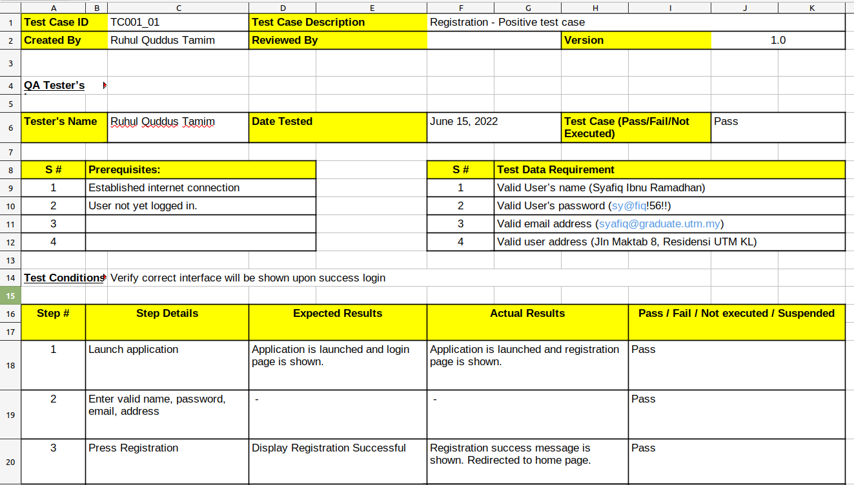

2.1.2 UC001: Registration (Negative Test Cases) :

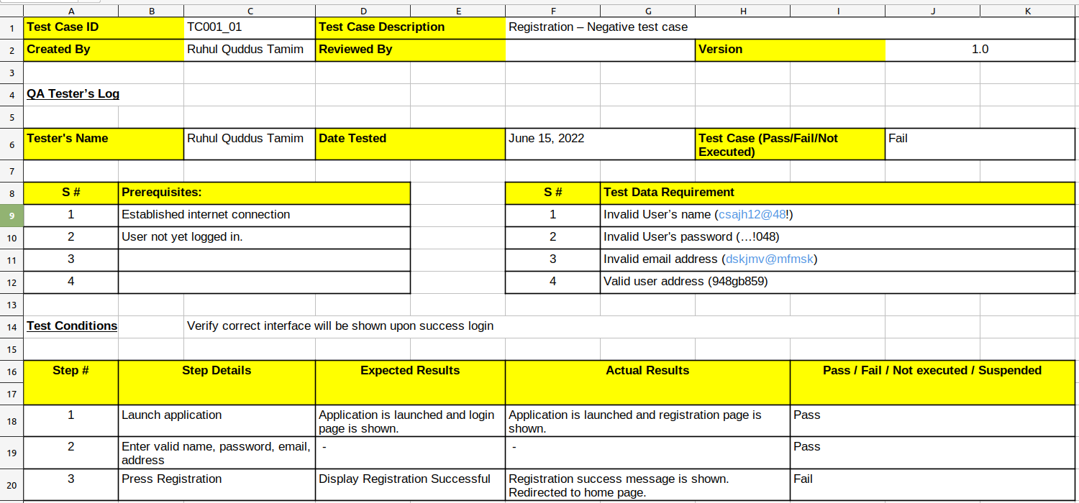

2.1.3 UC002: Login (Positive Test Cases) :

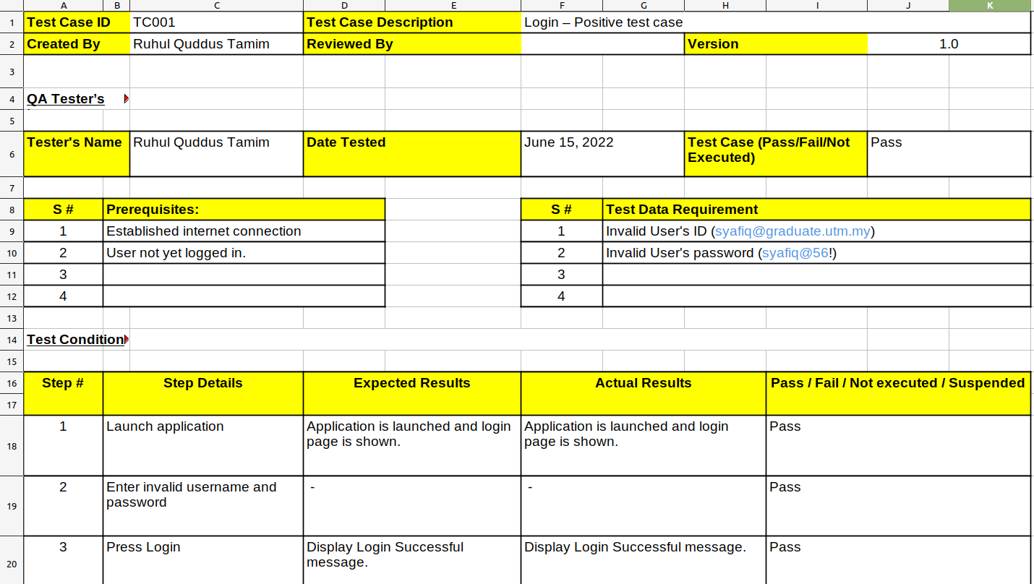

2.1.4 UC002: Login (Negative Test Cases)

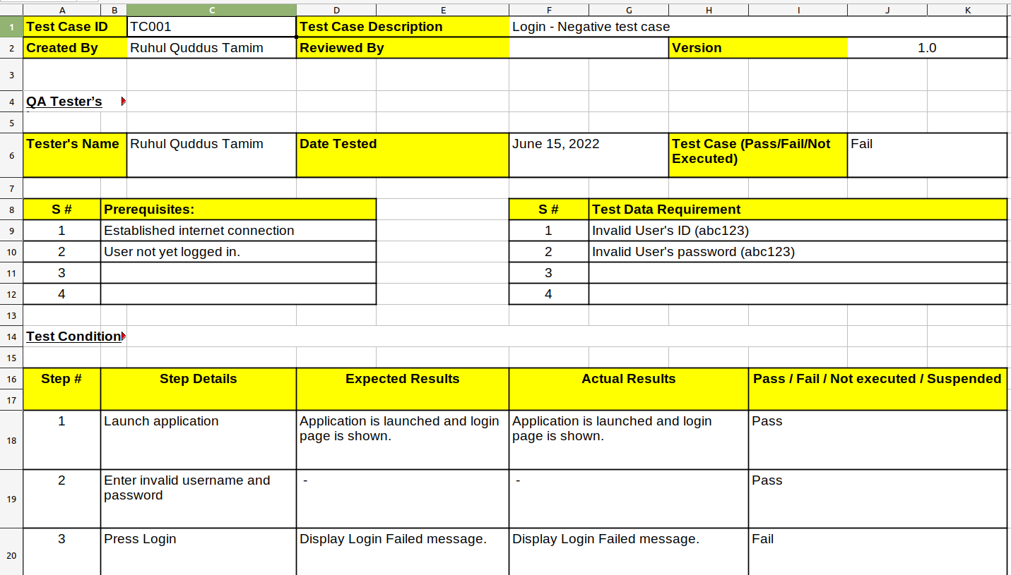

2.1.5 UC008: Feedback (Positive Test Cases) :

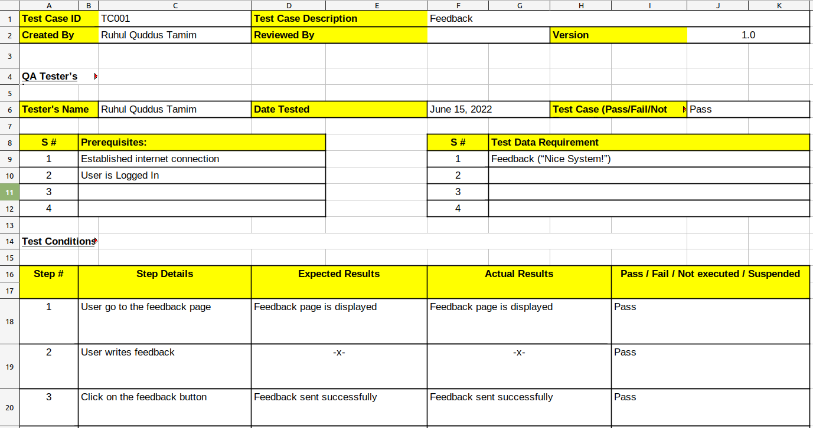

2.1.6 UC008: Feedback (Negative Test Cases) :
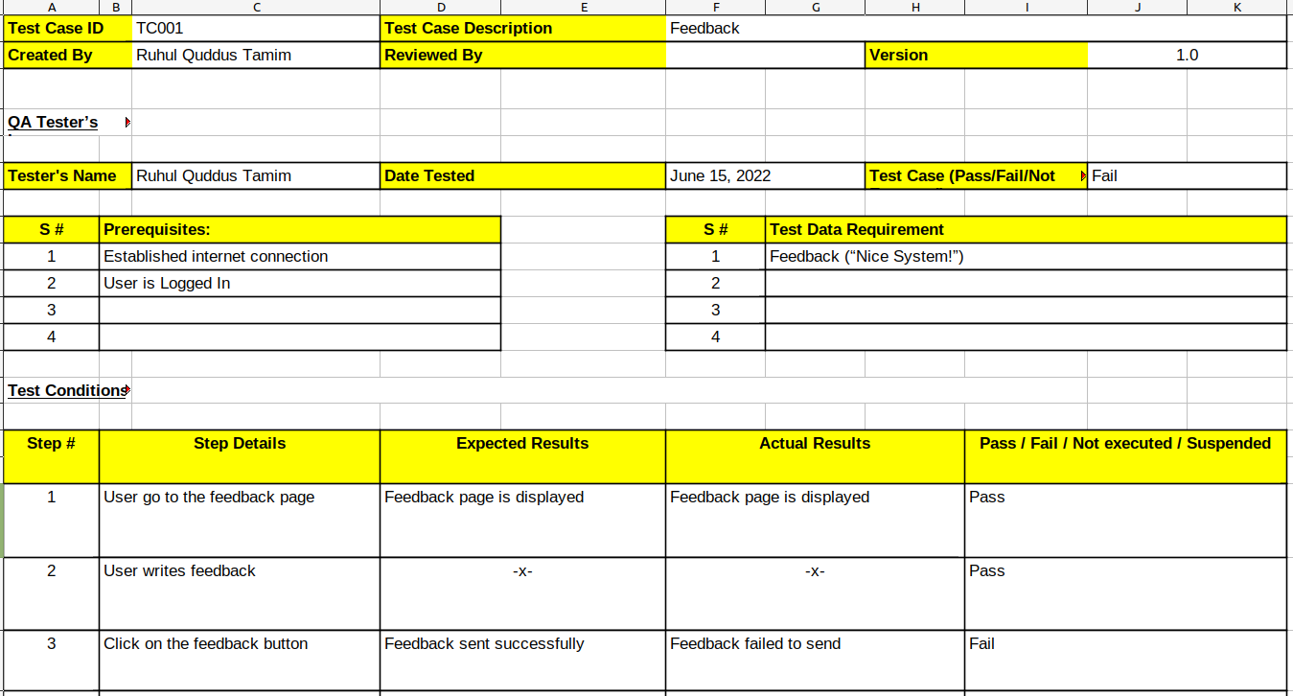

2.1.7 UC009: Check Results (Positive Test Cases) :

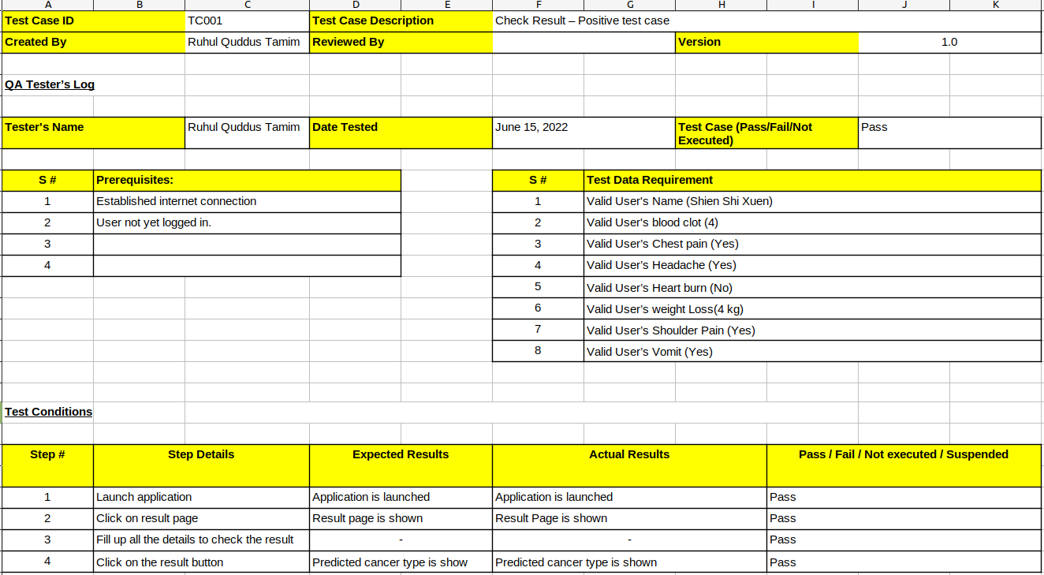

2.1.8 UC009: Check Results (Negative Test Cases) :

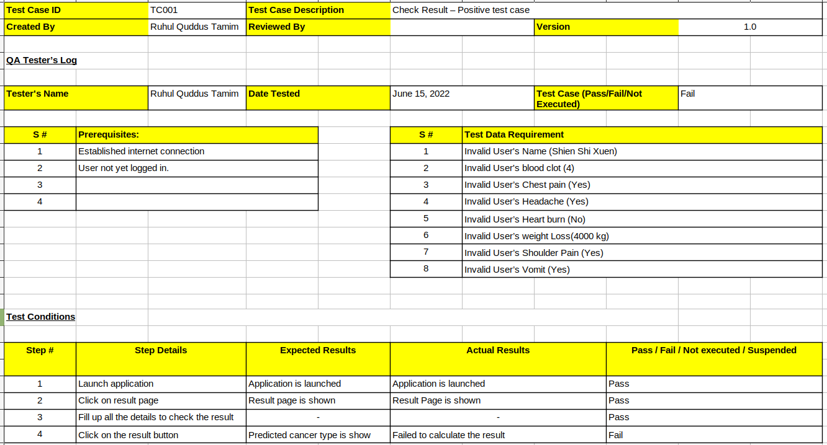

2.2 Test TC002 for Module <Admin Module>

This test contains the following test cases:

2.2.1 UC003: Add Doctor (Positive Test Cases) :
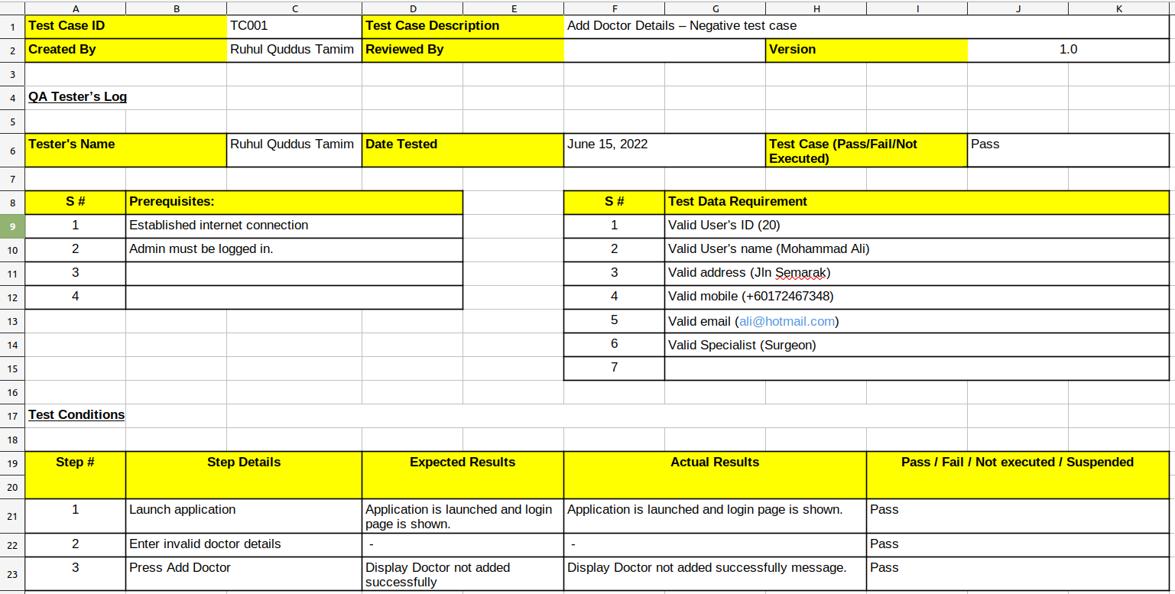

2.2.2 UC003: Add Doctor (Negative Test Cases) :

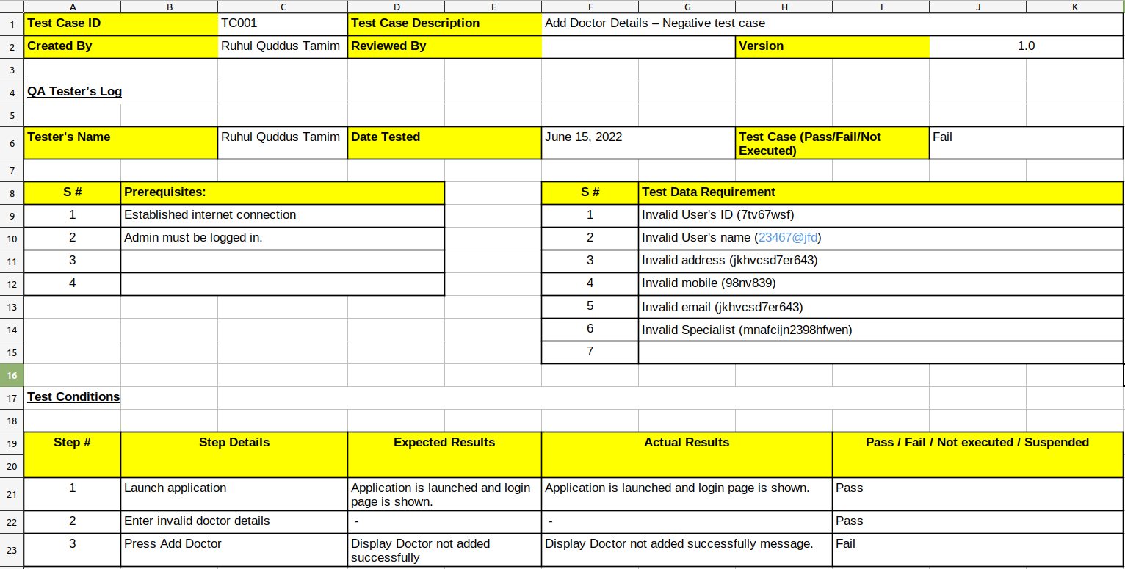

2.2.3 UC004: View Doctor (Positive Test Cases) :

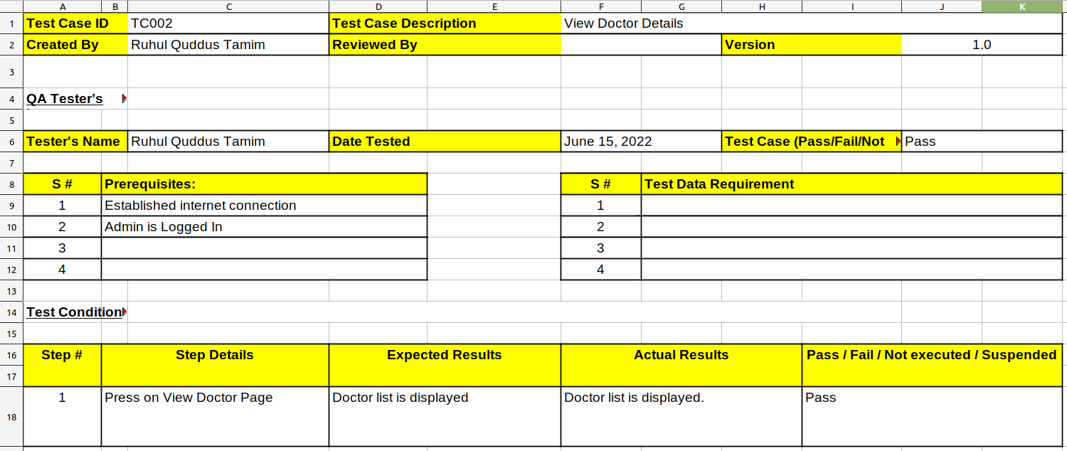

2.2.4 UC004: View Doctor (Negative Test Cases) :

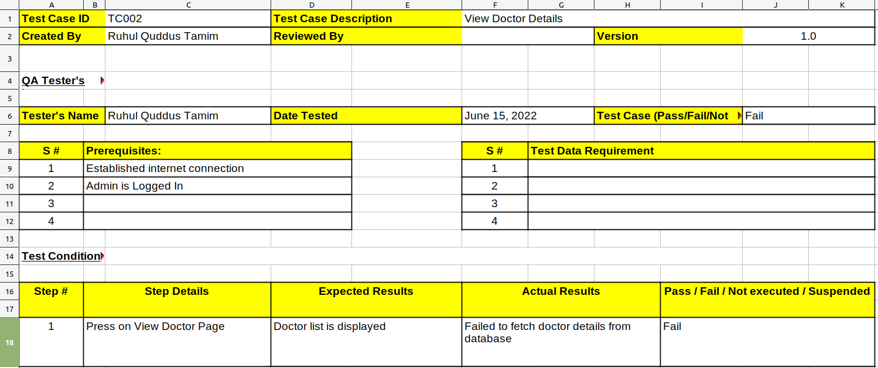

2.2.5 UC005: Add Training Data (Positive Test Cases) :

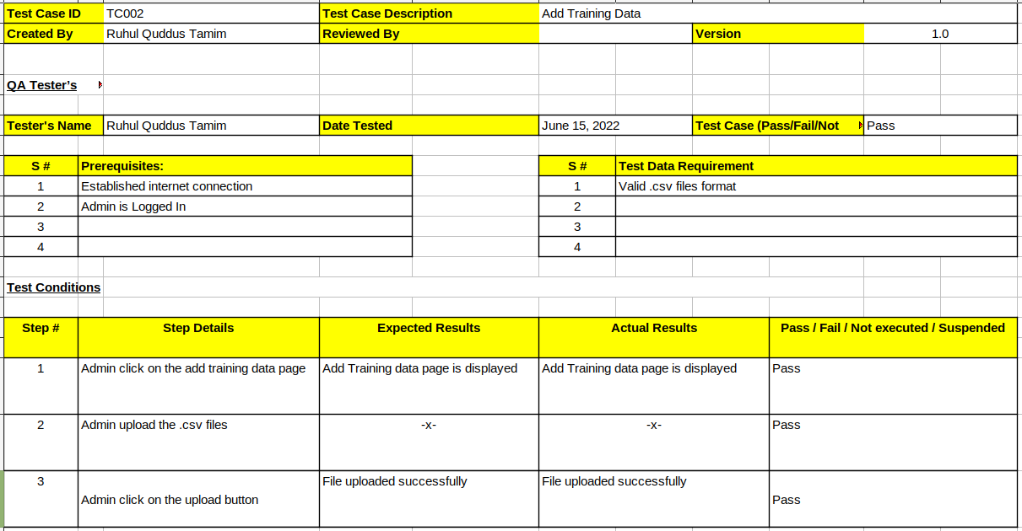

2.2.6 UC005: Add Training Data (Negative Test Cases) :

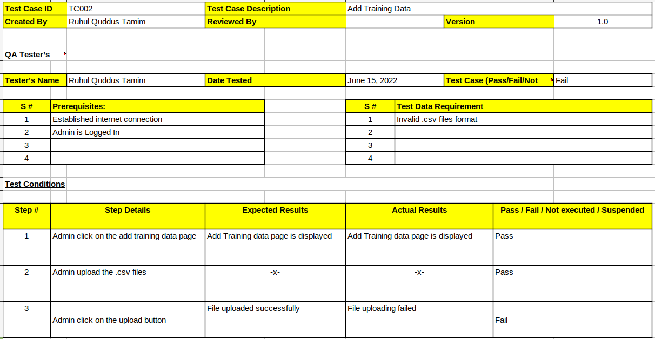

2.2.7 UC006: View Training Data (Positive Test Cases) :

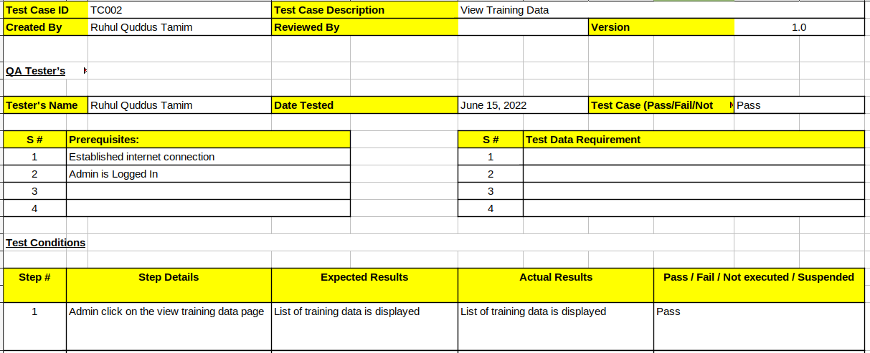

2.2.8 UC006: View Training Data (Negative Test Cases) :

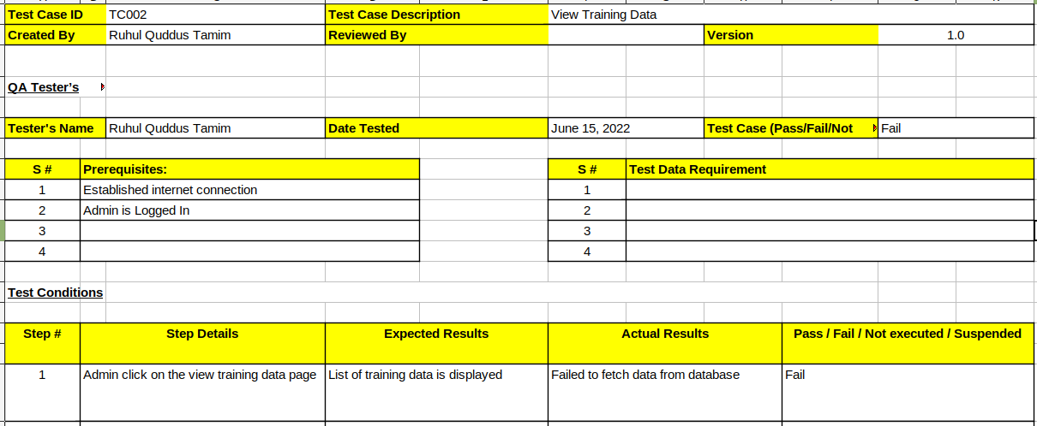

2.2.9 UC006: View User Details (Positive Test Cases) :

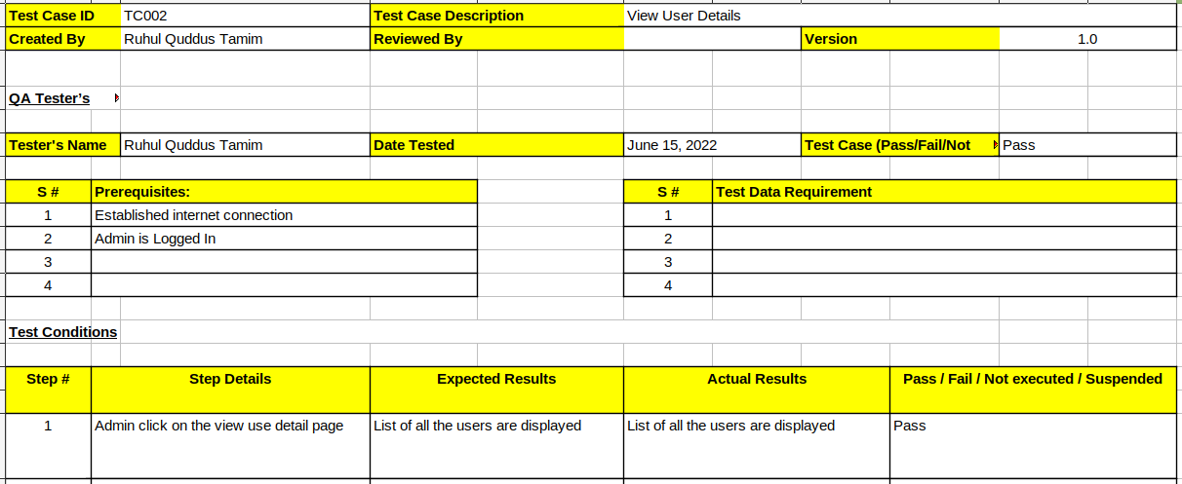

2.2.10 UC006: View User Details (Negative Test Cases) :

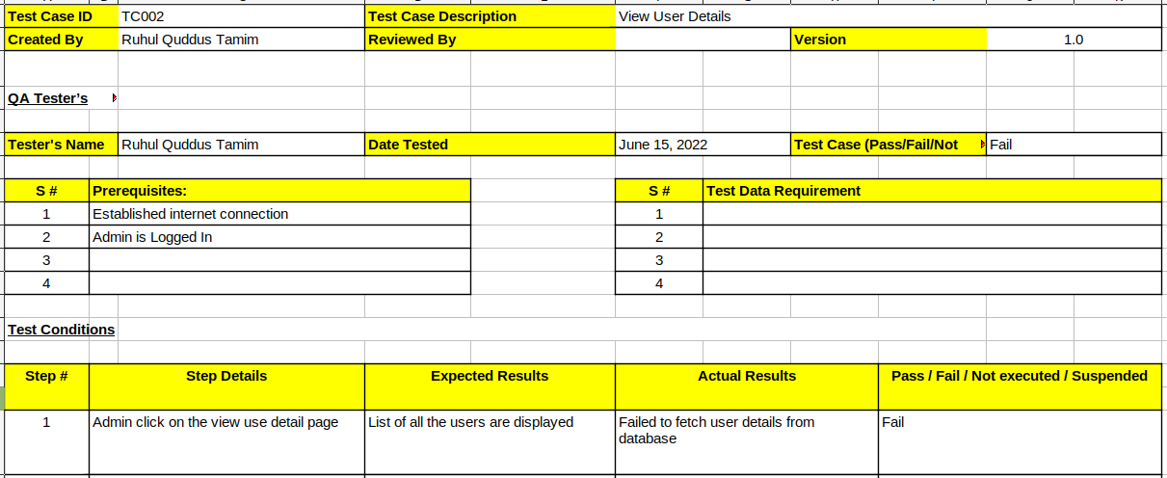

3.0 Test Approach Analysis

UC001: Registration
- Username must have at least 6 characters and at maximum 10
- Password must have at least 1 character, 1 number and 1 symbol
- Password length must be between 6 to 10
Username
EP class 1 (valid): 5 < username < 11
EP class 2 (invalid): username < 6
EP class 3 (invalid): username > 10
BVA values for username: 5, 6, 10, 11

Password
EP class 1 (valid): 5 < password < 11
EP class 2 (invalid): password < 6
EP class 3 (invalid): password > 10
EP class 4 (valid): password {character, number, symbol}
EP class 5 (invalid): password {character, number}
EP class 6 (invalid): password {character, symbol}
EP class 7 (invalid): password {number, symbol}
EP class 8 (invalid): password {character} | password {number} | password {symbol}

UC002: Login
- Username must have at least 6 characters and at maximum 10
- Password must have at least 1 character, 1 number and 1 symbol
- Password length must be between 6 to 10
Username
EP class 1 (valid): 5 < username < 11
EP class 2 (invalid): username < 6
EP class 3 (invalid): username > 10
BVA values for username: 5, 6, 10, 11

Password
EP class 1 (valid): 5 < password < 11
EP class 2 (invalid): password < 6
EP class 3 (invalid): password > 10
EP class 4 (valid): password {character, number, symbol}
EP class 5 (invalid): password {character, number}
EP class 6 (invalid): password {character, symbol}
EP class 7 (invalid): password {number, symbol}
EP class 8 (invalid): password {character} | password {number} | password {symbol}
EP class 9 (invalid): password other than {character, number, symbol}
BVA values for password: 5, 6, 10, 11
Boolean values: {character, number, symbol}, {character, number}, {character, symbol}, {number, symbol}, password {character} | password {number} | password {symbol}, password other than {character, number, symbol}

4.0 Additional Material

APPENDIX A. TRACEABILITY MATRIX

Test Case ID | Use Case ID/  Sequence Diagram ID | Package ID
TC001 for <User Module>  - TC001_01  - TC001_02  - TC001_03  - TC001_03  - TC001_04  - TC001_05  - TC001_06  - TC001_07  - TC001_08 | - X - | P002
TC002 for <Admin Module>  - TC002_01  - TC002_02  - TC002_03  - TC003_04 | UC003  - SD001  UC004  - SSD004  UC005  - SD002  UC006  - SD005  UC007  - SD006  UC008  - SD003 | P001

